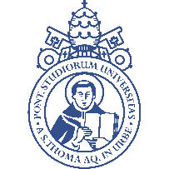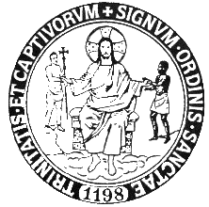

PONTIFICIA UNIVERSITÀ SAN TOMMASO D’AQUINO
SOLIDARIETÀ INTERNAZIONALE TRINITARIA (ORDINE DELLA SANTISSIMA TRINITÀ E DEGLI SCHIAVI)
CATTEDRA SULLA LIBERTÀ RELIGIOSA “GIOVANNI DE MATHA”

Reverend Father,
The Trinitarian Order since its foundation in 1198 has developed an apostolate in the context of Religious Freedom. Even today his activity focuses on the charism received from St. John of Matha and makes his efforts to help those persecuted because of the faith.
In this regard, the "St. John de Matha" Chair on Religious Freedom was created at the Pontifical University of St. Thomas Aquinas (Angelicum). Therefore, reflecting and discussing this aspect, it is possible to create an effective collaboration in the construction of cultures. The theme of religious freedom represents a real challenge for interreligious dialogue. On the one hand we can affirm that religious freedom is an indispensable condition for interreligious dialogue because it recalls a cardinal principle, namely respect for every person and every religious tradition.
The Chair will make different approaches to fundamental themes such as the meaning of religious freedom in the Scriptures, in the history and in the Magisterium of the Church. We will touch on the civil and political aspects of this right in principle. Finally, recognizing that religious freedom is not an argument in favor of theory, we will listen to witnesses and builders of freedom in countries that lack it.
In this sense, the professors are religious and lay specialists in Scripture, History, Dogmatics and Politics.
The lessons will be offered from an online platform, so they can be followed from anywhere in the world. But for people who live in Rome, they can participate directly in Angelicum University. In addition, a total of 3 ECTS credits will be offered for university students.
For those who wish to participate as auditors, the possibility will always be open to attend this course on Religious Freedom in the world. This course is very suitable for the constant formation of religious. People who want to work in the actualization of Religious Freedom and ask to join as listeners, without having to take any exam. In this sense, the lessons can be followed to have a clear education on the subject.
For auditors, the tuition fee for the course is 125 euros, while for those guests with the possibility of European credits it will be 330 euros.
For registration and information, you can contact the Angelicum University, specifically in the secretary of the Mater Ecclesiae institute.
Thank you for your cooperation. We hope that there are many men and women religious who find this course interesting for their formation.
Union of prayers

I attach Program and calendar.

